28. Strain Analysis with the Rf/φ Method

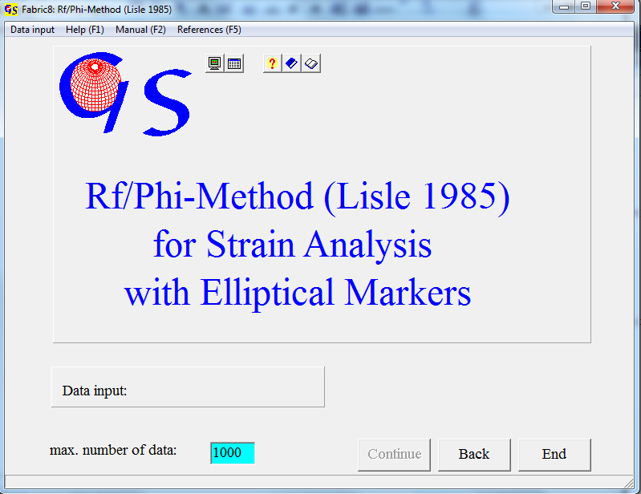
Fig. 1

The Rf/φ method allows strain analysis with primarily elliptical objects. The method was introduced by R. Lisle (1985):
The finite ellipticity (R_{f}) of objects and the orientation of the finite ellipses are a result of the deformation of the initial ellipticity, the initial orientation, and the ellipticity of the strain ellipse (R_{s}) and its orientation. Objects with the same R_{i} and different orientation show, after affine deformation, uniform patterns which can be shown by curves (R_{i} curves), in which R_{f} is drawn versus the finite orientation φ. Αn affine deformation of objects with different ellipticity but same orientation also results in R_{f}/φ curves (Θ curves).
Fig. 1 shows the start form of the program. In the menu "Data input" (Fig. 2) you can choose between input from an image or from an Rf/phi file. In such a file the long and short axes of measured ellipses and the angles between the long axes and a horizontal line are saved.

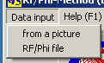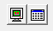
Fig. 2
When you click on "Rf/Phi file", all *.RFI files of the active folder appear (Fig. 3).

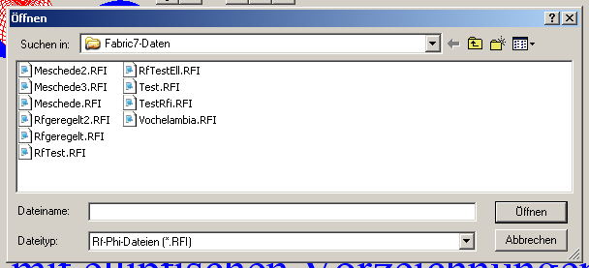
Fig. 3

When you click on on one of these two options, the button "Continue" becomes active. It opens the next form. With the option "From a picture" the form of Fig. 4 appears.Press "Start" and click on "Import picture".
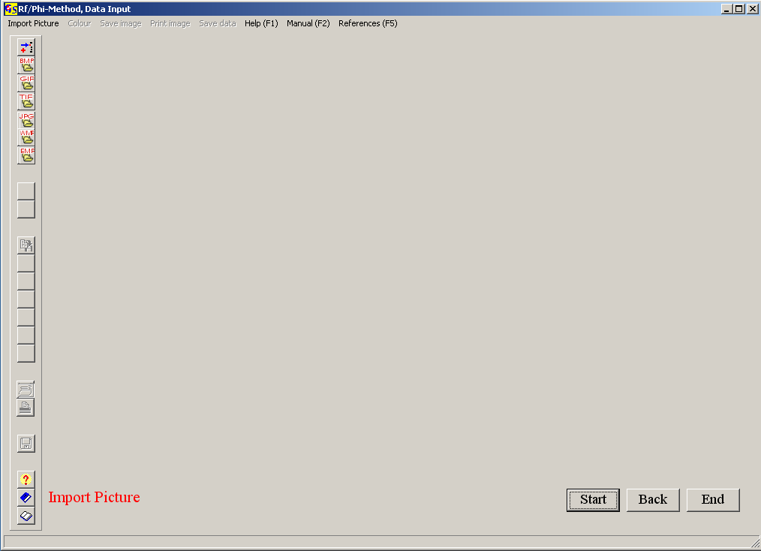
Fig. 4

The import of a picture and cut out is the same as described in program 26.
Fig. 5 shows the imported picture.

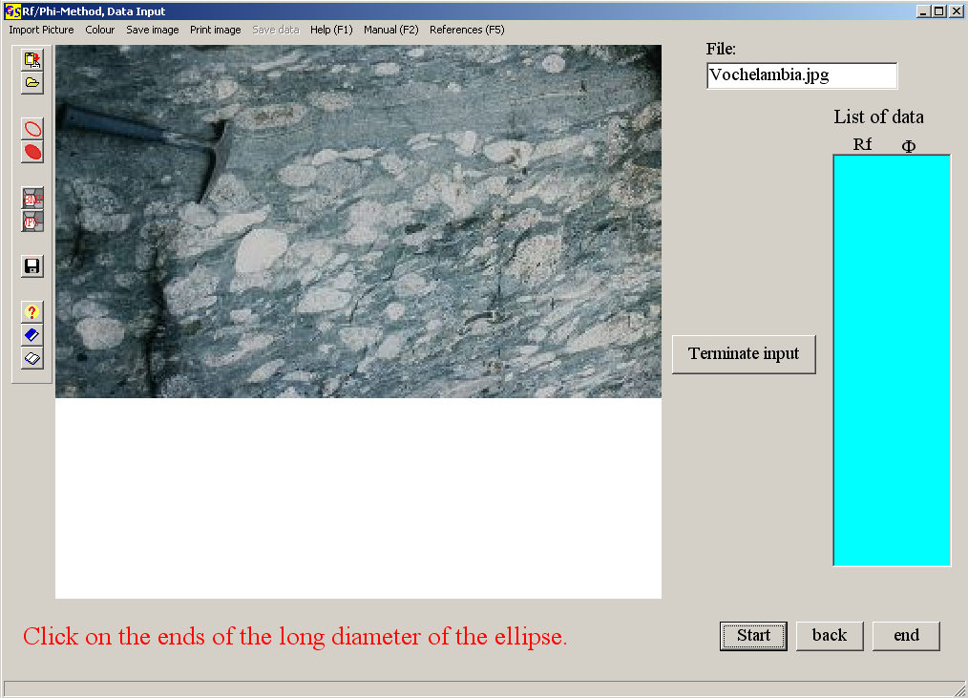
Fig. 5

Once the picture of the elliptical objects is displayed, you click on the ends of the long and short diameters of the elliptic objects. Each finished object will be overlain by an ellipse with a colour which can be chosen from the menu "Colour" (Fig. 6).
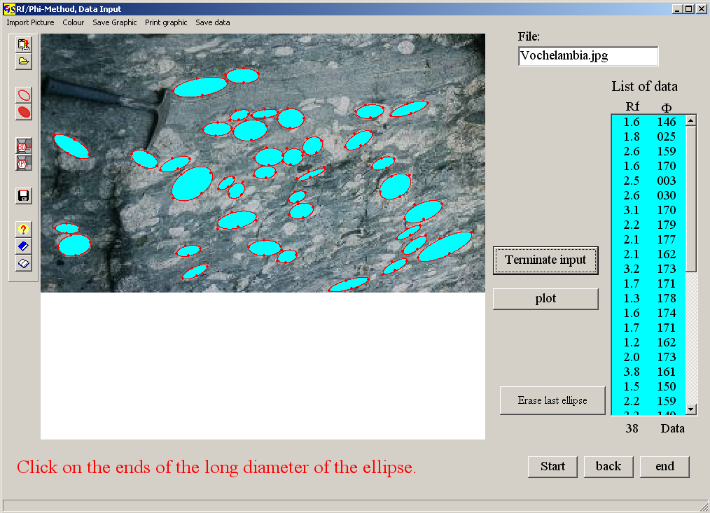
Fig. 6

The finite ellipticities and the angles between the long axes and a horizontal line are shown in the list of data on the right side.
Press the button "Terminate input" after the diameters of the last object are clicked. Now the button "Plot" appears. The image (Fig. 6) can now be saved and/or printed. The button "Plot" opens the graphic form for the results which contains the Rf/phi diagram (with Rf in logarithmic scale) and the calculated parameters (Fig. 7). From the symmetry of the distribution the vector mean of the Phi-values and the harmonic mean of the Rf-values is calculated (horizontal and vertical line). The symmetry index (0.97) is calculated from the numbers of values in the quadrants. They are compared with values calculated by Lisle (0.51).
The symmetry index is:

I_{sym} = 1 – (|n_{A} – n_{B}| + |n_{C} – n_{D}|) / N

(A – D are the quadrants in Fig. 7)

When the index is larger then Lisle's value, the distribution is probably symmetrical. A smaller value may point to an initial preferred orientation. The probable R_{s} value, i.e. the ellipticity of the strain ellipse can be read from the minimum of the chi² curve (Fig. 8).

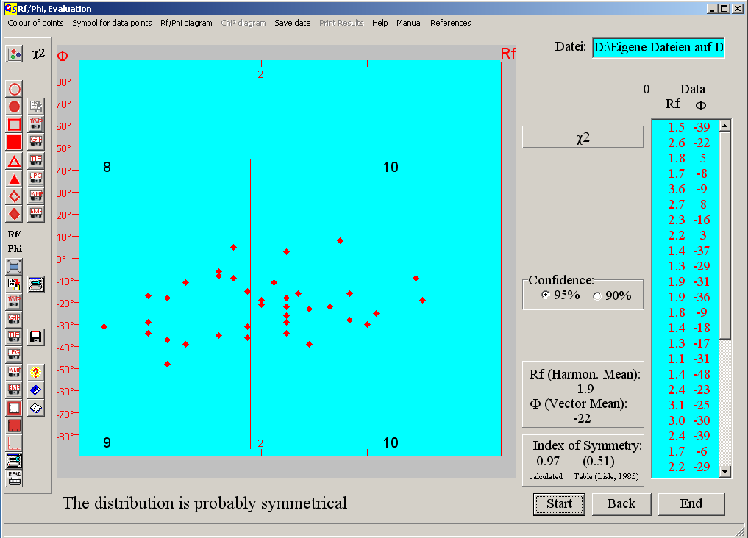
Fig. 7
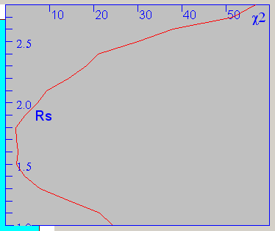
Fig. 8

The derivation of these values is explained by Lisle (1985).
Colour and shape of the data points can be chosen in the relevant menus. The options of the menus "Rf/Phi-Diagram" and "Chi²-Diagram" (Fig. 9) are described in program 3.

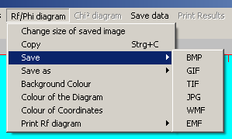
Fig. 9

Both images can be printed with the "Print Rf diagram" of the "Print chi²-diagram". Data and results can be saved with "Save data" and "Save results".

